**JPM Practicum Project**

**Topic: An Arbitrage-free SVI Volatility Surface Method to Calibrate Local Volatility Based on SP500**

**Name：Honglin Qian**

**University of Illinois Urbana-Champaign**

**Date: 2024 – 5 – 1**

**Introduction: SVI**

SVI (Stochastic Volatility Inspired) and SSVI (Surface Stochastic Volatility Inspired) are methods used in the financial industry for modeling volatility surfaces. They play a crucial role in options pricing and risk management.

**1. SVI (Stochastic Volatility Inspired)**

SVI is a model introduced by Jim Gatheral for fitting the implied volatility surface observed in the options market. Implied volatility is the market's forecast of the volatility of the underlying asset, and it varies with different strike prices and maturities. SVI uses a simple parametric formula to fit the implied volatility surface based on market data. The formula of **Raw SVI Parameterization** is typically expressed as:

Where:

* is the log-moneyness (logarithm of the strike price relative to the spot price).
* are parameters that need to be calibrated.
* represents total implied variance.

SVI is mainly used for:

* Fitting the implied volatility surface in the options market.
* Smoothing market data through a parametric model.
* Assisting in options pricing and designing hedging strategies.

It follows immediately that changes in the parameters have the following effects:

* Increasing increases the general level of variance, a vertical translation of the smile.
* Increasing increases the slopes of both the put and call wings, tightening the smile.
* Increasing decreases the slope of the left wing, a counter clockwise rotation of the smile.
* Increasing translates the smile to the right.
* Increasing reduces the at-the-money (ATM) curvature of the smile.

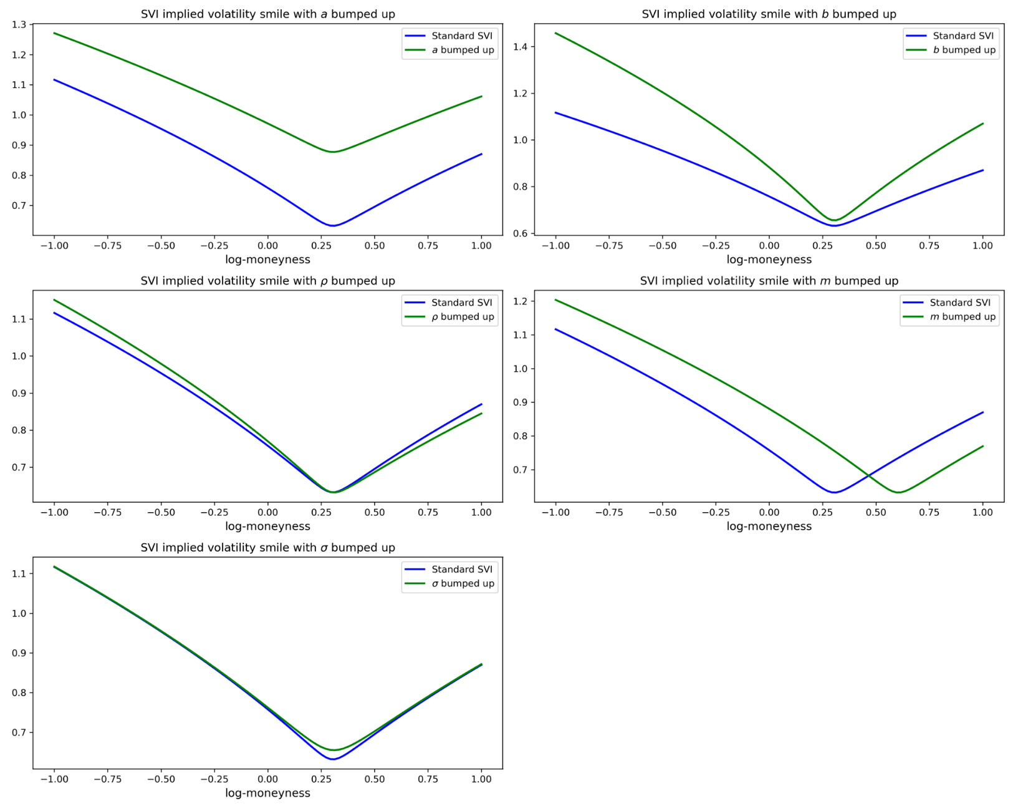

**2. SSVI (Surface Stochastic Volatility Inspired)**

SSVI is an extension of SVI that captures the dynamic evolution of the entire volatility surface. It introduces a time dimension into the SVI model to describe the time evolution of the volatility surface. SSVI is better suited to describe the behavior of implied volatility across different maturities and strike prices. The SSVI formula is an extension of **Natural SVI Parameterization** to include the time dimension, typically expressed as:

Where:

* is at-the-money implied total variance.
* is total implied variance.
* is a smooth function.

SSVI is mainly used for:

* Modeling the entire volatility surface, applicable to different maturities.
* Providing a more comprehensive framework for options pricing and risk management.
* Capturing the dynamic changes and trends in implied volatility in the market.

Overall, SVI and SSVI are essential tools in financial mathematics for capturing the volatility structure in the options market, particularly in high-frequency trading and complex financial product pricing.

**3. Free of Arbitrage**

A volatility surface is free of static arbitrage if and only if the following conditions are satisfied:

* It is free of calendar spread arbitrage.
* Each time slice is free of butterfly arbitrage.

**Calendar Spread Arbitrage:**

The volatility surface is **free of calendar spread arbitrage** if and only if:

**Butterfly Arbitrage:**

A slice **(fixed T )** is said to be **free of butterfly arbitrage** if the corresponding density is non-negative:

**Since here we just calibration 2-dimensional SVI Parameterization (fixed T ), we just check free of butterfly arbitrage.**

**Introduction : Surface SVI Parameterization**

**1 Natural SVI Parameterization:**

For a given parameter set , the **natural SVI parameterization** of total implied variance reads:

Where:

**2 SSVI:**

We now introduce a class of SVI volatility surfaces—which we shall call SSVI (for ‘Surface SVI’)—**as an extension of the natural SVI parameterization.**

We refer to as SSVI the surface defined by:

Where:

* : A scalar parameter at time , typically related to the total variance.
* **The standardized strike price,** where  is the strike price and is the forward price. This variable reflects how far the strike price  is from the forward price .
* : The correlation coefficient, which controls the **skewness** of the implied volatility curve.
* : A function dependent on ​, used to adjust the **influence of volatility across different time horizons.**

SSVI corresponds to the natural SVI volatility surface parameterization with

**3 Example of**

3.1 Heston-like parameterization:

3.2 Power-law parameterization:

**4 Free of Arbitrage**

The SSVI surface is **free of static arbitrage** if the following conditions are satisfied:

Where, 1 and 2 promise SSVI surface is free of calendar arbitrage, while 3 and 4 promise SSVI surface is free of butterfly arbitrage.

**Local Volatility Calibration Based on SSVI**

**1 Math Formula:**

1.1 We consider the following SSVI parameterization of the total implied variance surface:

Where:

* denotes the total at-the-money variance.
* denotes the log-moneyness.

1.2 We consider the following smooth function:

1.3 Then, the local volatility function is:

And

Hence, we need to calibrate 6 parameters:

The parameter in this context is primarily used to describe the evolution of the at-the-money (ATM) volatility over time. It is defined using a double mean-reverting (DMR) model, which accounts for two different mean-reverting processes to describe both short-term and long-term volatility behavior. To better understand the significance of , let's break down the formula:

Meaning of Each Term in the Formula:

1. :

* This is a linear term representing the ATM volatility increasing proportionally with time . It usually captures the long-term linear trend in the volatility.
* This is the first mean-reverting term, where represents the short-term volatility level, and is the long-term mean of the ATM volatility.
* is the **mean-reversion speed for short-term** volatility, dictating how quickly the short-term volatility reverts to the long-term mean .
* The factor is an adjustment that stabilizes over time, indicating the process of volatility reverting from its initial level towards its long-term average.

3. :

* This is the second mean-reverting term, where is the long-term volatility level.
* is the **mean-reversion speed for** **long-term** volatility, like but acting over a longer time horizon.
* This term is more complex and accounts for the transition of volatility from the short-term level to the long-term level, considering both mean-reversion speeds and .

**Overall Significance of :**

represents the evolution of ATM volatility over time, incorporating both short-term and long-term characteristics of volatility. Through this formula, captures how volatility gradually reverts from its initial level to its long-term mean over different time scales. The mean-reversion speeds and determine how quickly this process occurs.

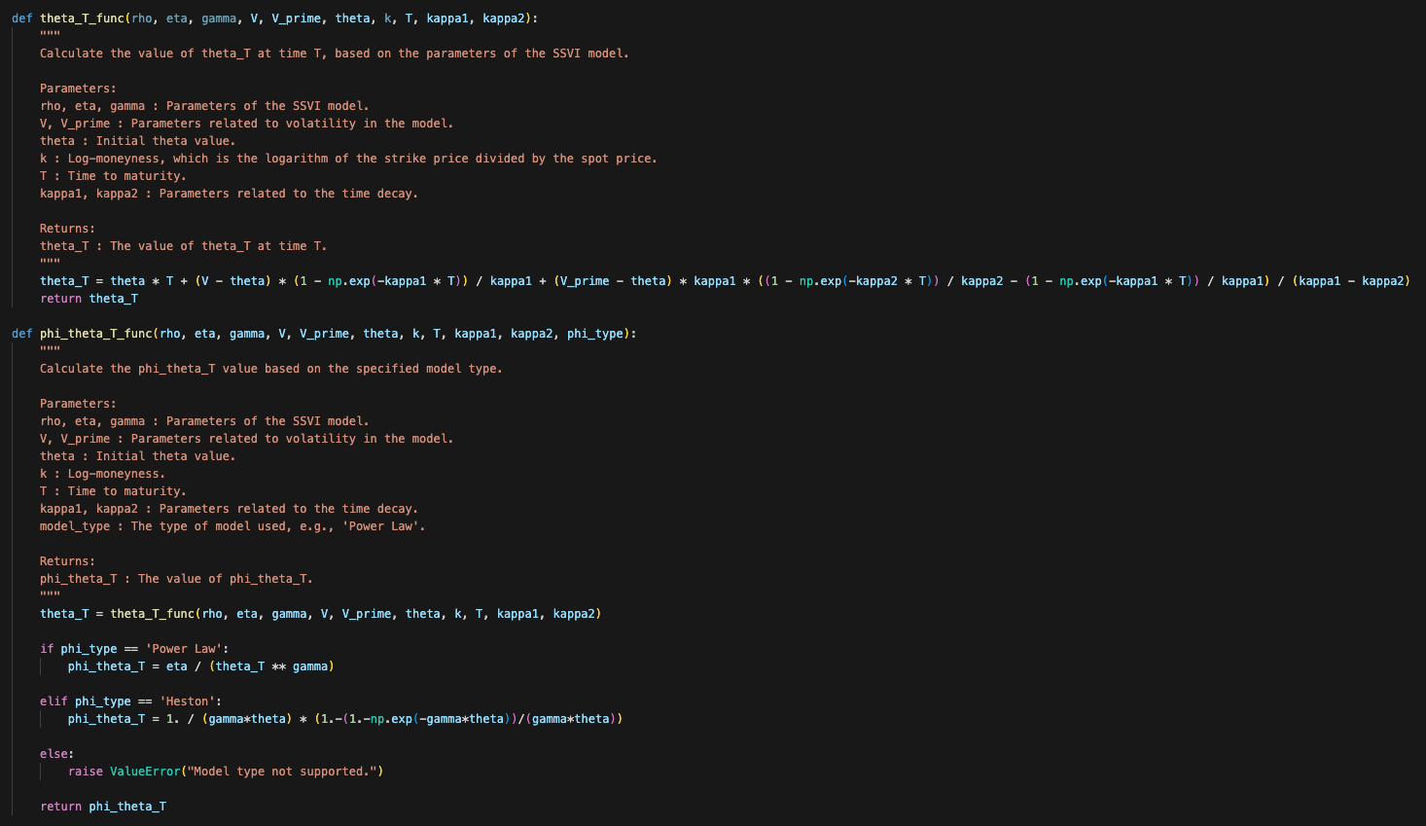

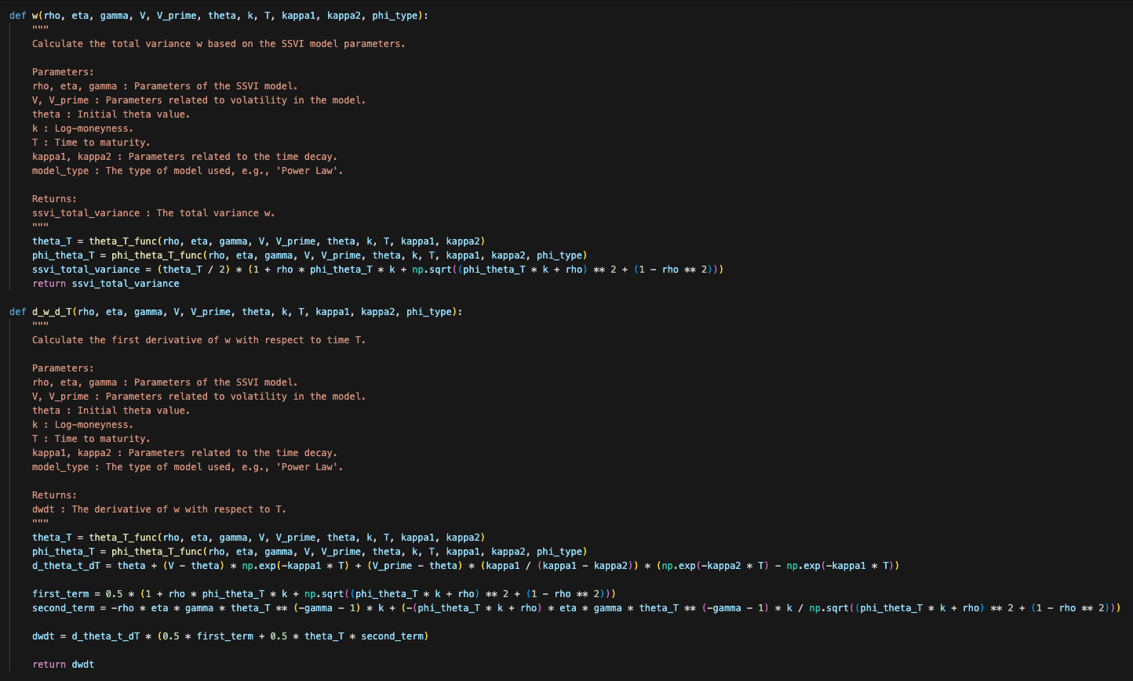

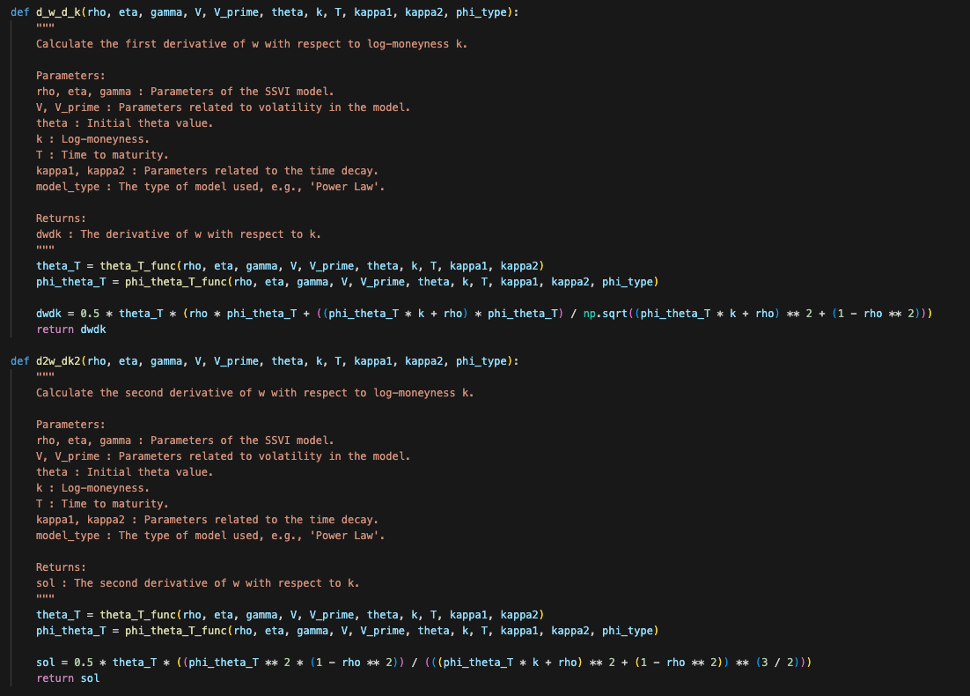

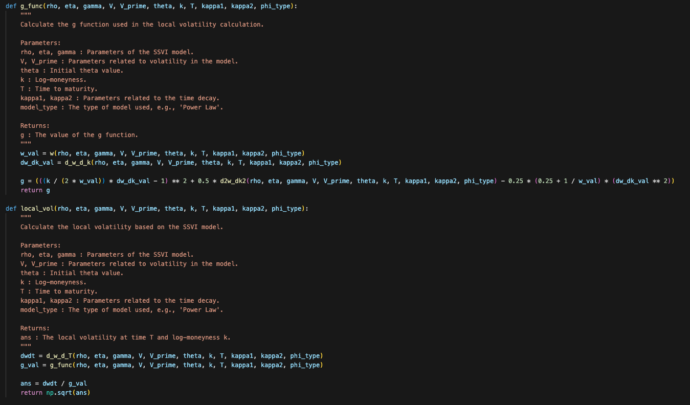

**2 Parameter Calibration:**

Let's make two direct calibrations (no quasi-explicit reparameterization). One with **Brute Force** global optimization and a refinement with a simplex algorithm, and the second through a **Differential Evolution - DE**, optimization refined by a L-BFGS-B method.

**Objective Function:**

**1. Brute-Force Search (Method = "brute")**

* **Principle:** Brute-force search is an exhaustive search method that evaluates the objective function at a grid of points within a defined range for each parameter. It is a simple, yet computationally expensive method because it checks every possible solution within the grid.
* **Mathematical Operation:**
  + The “brute( )” function systematically varies each parameter within its specified range (“bfranges”), with the number of grid points controlled by “ngrid”.
  + It evaluates the objective function “obj_fun_wrmse” at each point in the grid.
  + The method returns the point where the objective function reaches its minimum value, which is the optimal solution.
* **Usage:** This method is best when the search space is small and well-defined, and when the function has no local minima that could trap other optimization methods.

**2. Differential Evolution (Method = "DE")**

* **Principle:** Differential evolution (DE) is a stochastic population-based optimization method. It is a type of genetic algorithm that uses concepts of mutation, crossover, and selection to iteratively improve a population of candidate solutions.
* **Mathematical Operation:**
  + **Population Initialization:** A population of candidate solutions is randomly initialized within the bounds (bounds).
  + **Mutation:** For each candidate, a new candidate (mutant vector) is generated by adding the weighted difference between two randomly selected population members to a third one.
  + **Crossover:** The mutant vector is mixed with the original candidate vector to create a trial vector.
  + **Selection:** If the trial vector yields a lower objective function value than the original candidate, it replaces the original candidate.
  + This process is repeated for a specified number of generations or until a convergence criterion is met.
* **Usage:** Differential evolution is particularly useful for problems with complex landscapes, such as those with many local minima, because it is less likely to get trapped in a local minimum compared to traditional gradient-based methods.

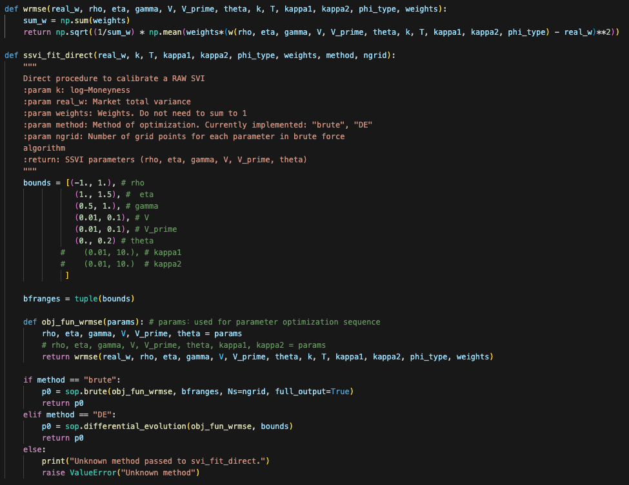

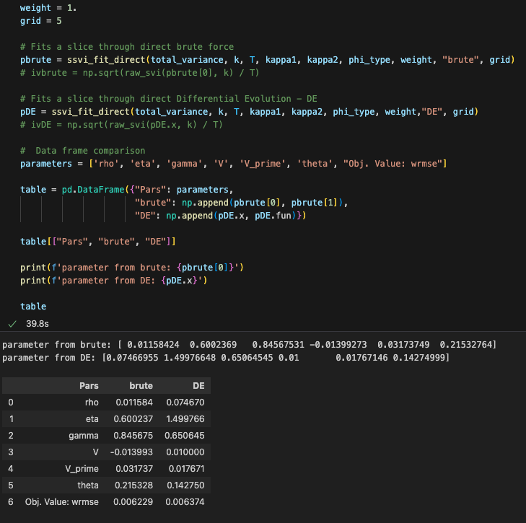

From table, we can see that there is no big difference between Brute method and DE method. Since DE method provide a faster calibration, we can utilize **Differential Evolution** method as our parameter calibration method.

**2 Free of Arbitrage Checking:**

The SSVI surface is **free of static arbitrage** if the following conditions are satisfied:

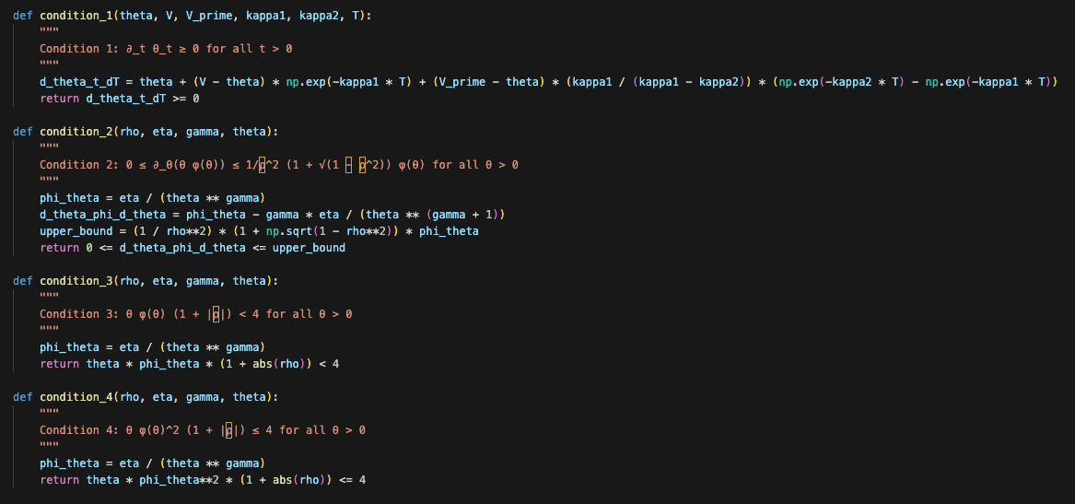

**3 Local Volatility Surface for SSVI:**

